Kindergarten Home Practice
January 24 - 28, 2022
Spelling Lesson 5
kid hid lid rid did have

Monday 1/24
- Math pages 321-322
- Recipe for reading pages 87-88
- Spelling Lesson 5- 2x each
- Get spelling test signed- it is in the back of the spelling book
Tuesday 1/25
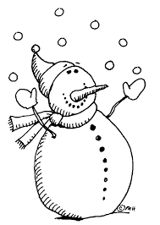
- Math IXL J.10
- Recipe for Reading page 89
- Spelling- draw two pictures, label and color each
Wednesday 1/26
- Dinosaur math worksheet (2 sided)
- Recipe for Reading page 90
- Spelling write 2 sentences
Thursday 1/27
- Math IXL L.1
- Recipe for Reading page 91
- Spelling 2x each
- spelling test tomorrow
- 12:30 dismissal tomorrow
Friday 1/28
- Math worksheet pages 329-330
- Recipe for Reading page 92 (Don’t forget to write the letters above each picture)
- Language Arts IXL C.3

